# 

# National University of Computer & Emerging Sciences – FAST Peshawar Campus

***Fundamental of management***

***Report 01***

***BCS-3A***

***Group 02***

*Abid Ali 22P-9053*

*Uzair Ahmad 22P-9021*

*Hamza Tahir 22P-9065*

*Abdul Ghani Khan 22P-9037*

***Organization: UPTEK***

***Manager: MR. NAVEED AMAN***

***Email: naveed.aman@uptek.com***

**Uptek:**

Uptek is a company that makes computer programs. They have been around for more than three years. They are known for hiring really good developers who are experts in their field. Uptek does many different things in software, like making custom programs for clients, giving advice on computer stuff, helping with ongoing support, and knowing a lot about different industries.

In simple words, Uptek is a well-established software company that is good at hiring smart developers and offers many services. They focus on making custom software, coming up with new ideas, and helping clients. This makes them a trusted partner for businesses looking for software solutions in today's competitive technology world.

**Hawthorne Studies:**

Even though the Hawthorne Studies mainly looked at factories, what they discovered about how people's feelings and motivation affect how much they get done can still matter for Uptek. Uptek knows that it's important for their employees to feel good and stay motivated, and this matches up with what Hawthorne Studies talked about when it comes to work.

**System Approach:**

Uptek uses a "systems approach," specifically a closed system, by looking at how different parts of their company are connected. They think about things like managing projects, making sure employees are happy, and how they work with clients. They know that making changes or improvements in one area can affect the whole company.

**Situational Approach:**

At Uptek, they take a tailored approach to software development strategies and project management methods. They adjust these based on what each client needs. They know that not every situation can be solved with the same solution, so they customize things to fit.

**Current Trends & Issues:**

To stay at the front of the software development industry, Uptek stays informed about the latest trends and problems. This means they keep up with new technologies, cybersecurity threats, and the best ways to do things in the industry. They do this so they can offer advanced solutions while also reducing risks effectively.

**Ethics:**

When it comes to Uptek, it's important to mention that they strongly believe in certain values. Their main values are honesty, integrity, and fairness in all their business dealings. This helps build trust with both clients and stakeholders.

**Workforce Diversity:**

Uptek understands the importance of having a diverse workforce. They encourage an inclusive environment where people from different backgrounds can share their unique viewpoints and skills. This diversity can result in increased creativity and better problem-solving.

**Entrepreneurship:**

Uptek, being a software development company, shows entrepreneurial qualities by creating its software products and platforms alongside offering customized solutions. This entrepreneurial mindset sparks innovation and helps the company grow.

**E-Business:**

Uptek adopts e-business methods by using digital technologies for client communication, managing projects, and marketing. They use online platforms to work with clients and provide their software solutions worldwide.

**Learning Org and Knowledge Management:**

Uptek encourages a culture of continuous learning among its employees, where they are motivated to keep improving their skills and knowledge. They also have systems in place to manage knowledge effectively so they can collect and share valuable insights and the best ways of doing things.

**Quality Management:**

Uptek gives great importance to managing quality. They ensure that their software products and services meet very high standards by doing thorough testing and quality checks, and always trying to improve.

Uptek wants to provide outstanding software solutions and create a workplace that values ethics, diversity, innovation, and quality by using these ideas and methods in their work. This matches up with modern ways of managing a company.

***Meeting Picture*** 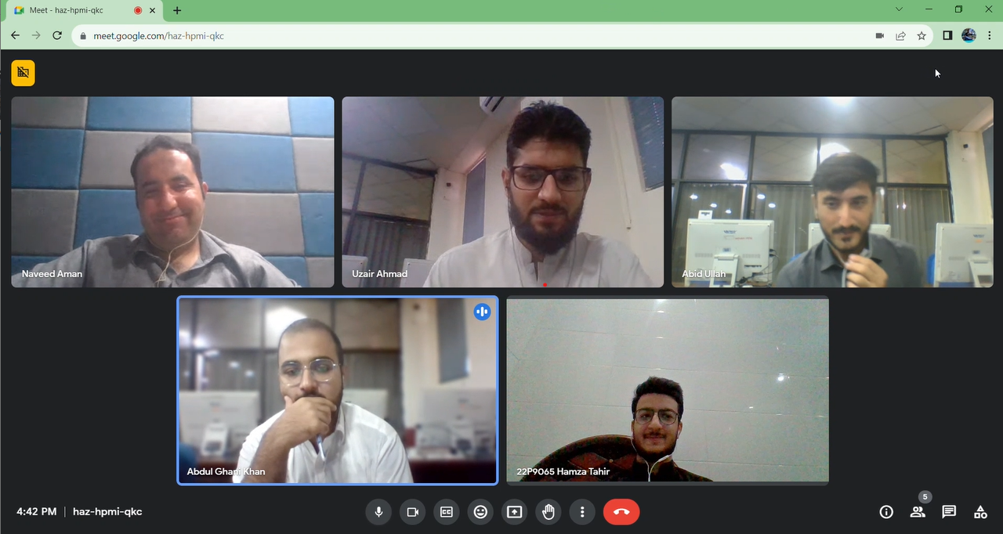

**Report-02**

**PESTLE Analysis**1) Government Rules and Support: The rules and help from the government can really help or hinder what Uptek can do. For example, they have to pay them taxes, but they also help ensure Uptek can make software by giving access to the internet.2) Money and Stability: Ensuring that there is enough money coming in to Uptek and feeling secure that it will stay at the same level. Including knowing how much money is worth in different countries and how they get their hands on the money to work with.3) Skilled team and Knowing Customers: Having a team that are good at their work and know what the customers want and like.4) Technology: Using good technology and keeping their ideas safe from other people knowing about them.5) Environment and Being Eco-Friendly: Must think about protecting the environment. All ways in which they can stop any damage being done to the earth.6) Legal Stuff: Following the law so people cannot take their ideas, make sure that peoples information is safe and that workers are not being mistreated.At the end of the day no matter what decision Uptek need to make they have to think about all these to make the first one. As it will affect how well the company does and other choices that will be made.

**Social Responsibility Initiatives:**

Current Initiatives: At present Uptek as an organization with social responsibilities, participates in social activities. Our company supports local schools through provision of computer hardware and learning materials, enabling digital education among schoolchildren. Besides we also have an environmental department whereby we conduct environment cleanup exercises in the community towards a cleaner and healthy environment.

**Community Development Projects:**

In one of our recent community development initiatives, we partnered with an indigenous NGO towards setting up a vocational learning facility. Skill Development is a center that works with vulnerable youth to equip them with employable skills and sustainable source of income. Alignment with Community Needs: Uptek performs periodic needs evaluations and works with local leaders to determine that our strategies meet the requirements prevailing in the community. Our approach towardsaddressing the community’s challenges is active engagement into it and solving them altogether.

**Approaches to Social Responsibility:**

**Environmental Sustainability:**

They provide environmentally sustainable products and services. Our offices are energy efficient and we encourage to go paperless. Furthermore, together with environmentalists, we promote tree planting initiatives known as afforestation that contribute to the maintenance of biodiversity.

**Educational Initiatives:**

Uptek is a major company that offers sponsorship to schools for various online courses that help students improve their digital skills. We hold coding camps and STEM courses for the youth, motivating them to venture into the realm of technology.

**Impact Evaluation:**

We undertake continuous surveys and engage in community feedback to measure the effect of our social responsibility efforts. Such evaluations enable us to gauge the efficacy of our programs in making informed choices regarding enhancements and expansion of our projects.

**Managerial Ethics:**

Ethical Guidelines: The comprehensive policy guiding the managerial ethics at Uptek lays emphasis on integrity, honesty, and commitment to all stakeholders. We also train our employees on ethics, and they can file complaints via the secret way.

**Challenging Ethical Decision:**

We recently had a case of a client demanding some alterations that were potentially risky for users’ data confidentiality. It was necessary to maintain our ethical principles, which is why we had an open discussion with the client, indicating possible ethical implications. jointly, we were able to propose a measure that satisfied our customers’ requirements, while respecting user confidentiality as our guiding principle.

**Ensuring Ethical Behavior:**

We have made ethical behavior as part of our organization’s culture. Through ethic workshops, we continuously remind our staff on the ethical standards. Furthermore, our management team demonstrates appropriate ethical practice through personal examples that creates a culture based on honesty and responsibility.

**Integration with Business Practices:**

Integration into Operations: It would be impossible to separate social responsibility from our activities. We consider this one of the most important criteria when choosing our vendors as they have to share our ethics and respect for sustainability matters. In addition, we have an open policy that encourages employees to volunteer in socially friendly activities during working hours.

**Policies and Corporate Culture:**

The company, Uptek, has implemented measures of ensuring social responsibility and the conservation environment. They have to be well explained and understood by every staff member, it also forms part of their performance evaluation. The company’s social responsibility, the culture that prioritizes giving back to the community and acting as a good corporate citizen.

**Balancing with Business Objectives:**

With respect to social responsibility is one of the essences of our corporate image and yet it’s not something else that has nothing to do with our business goals. We have established long-term partnerships through a number of CSR activities that have helped us improve on the relationship with the community as well as our clients thus building up on our reputable brand name.

**Stakeholder Engagement:**

Employee Participation: Uptek motivates its staff to participate in social responsibilities through volunteering programs and community outreach. The management encourages our employees to take on initiatives and own them, instilling self-confidence and self-esteem for contributing to building a better world.

**Collaborations and Partnerships:**

Together with various local NGOs, schools, and state agencies, we ensure that our corporate social responsibility is highly effective. We form partnerships in order to use combined experience and skills for a more comprehensive solution of local problems.

**Communication and Feedback:**

Internal newsletters, social media and community events are means by which we communicate our social responsibility initiatives. Stakeholders like employees, clients and even the community constantly give feedback which is analyzed periodically in this way. By so doing, we are in a position to improve the efficiency of our programs and anticipate the evolving requirements of the community.

**Future Plans and Innovation:**

Future Initiatives: Uptek will also create scholarships aimed at financing tertiary-level studies for meritorious candidates with limited financial means. Additionally, we intend to partner with other environmental organizations for massive tree-planting programs that play a significant role in the conservation of the environment.

**Innovation in CSR:**

CSR is driven by innovation, which is the key to our search for a way to use modern technology, including mobile applications, to promote pedagogical programs and interactive child learning. We also focus on the development of sustainable practices for environmental conservation and promoting green lifestyles in our neighborhood.

**Measuring Innovation Impact:**

Our innovative initiatives are measured based on parameters like increased student enrollment, better grades by students, and tree count. We use these metrics to evaluate whether or not we are making progress toward the goal we established, based on how we’ve been pioneering new ways to be socially responsible.

**Identify Problem & Criteria: The decision process for Uptek starts by them identifying issues and knowing what they want. They have clear criteria on cost, if the tech is feasible, if there is market demand, does it fit their goals as a company?Develop & Analyze Options:** They start the decision process by brainstorming and researching to create alternatives. They then way the pros and cons of each alternative with a team and expert, and pick the best alternative according to its criteria.**Implement:** Once a decision is made Uptek develops a plan, sets goals, assign tasks, and develop a tracking to reach its goals to set its plans in motion.**Evaluate:** Lastly during the decision process Uptek checks to see if their decision is working. They look at indicators that give them feedback from others. If it’s wrong, then they make necessary changes.**Step 2: Construct Decision Criteria**Cost. Uptek pays attention to the financial aspects. What is the cost of the decision and the cost of keeping the decision in place. They look at the total cost of the decision what it takes to get it running, keep it running, and shut it down. They also look at if there is any chance to save money or make more money because of the decision.Risk. Uptek pays attention to the uncertainties. What could possibly go wrong? Uptek looks at what problems could come up and what is the badness of each one. These could be problems within the firm or external problems such as the technology, the market, or the work done. This information is used to avoid making decisions to fall into a trap and increase the chances of success.We make sure we are aiming for the right outcomes. We set clear goals for what success should look like. Then, we measure how well each decision will help us reach those goals. That can mean making more money, making customers happier, improving our products, or growing our market share. By thinking about these results, we pick the choice that best fits our big plans and brings the most positive results.

**Step 3: Assigning Weights to the Criteria**We give a weight to money to decide how important it is to us. A higher weight means we care more about money savings. For example, if we’re on a tight budget, we assign a higher weight to costs to be prudent about our finances.We give a weight to risks to decide how much we want to avoid problems. A higher weight means we care more about avoiding potential problems. If we’re facing many uncertainties, we assign a higher weight to Risks to be cautious.We give a weight to outcomes to determine how much we value achieving good results. A higher weight means we place a premium on results. If we have definite goals—for instance, to grow our market or enhance our products—we assign a higher weight to Outcomes in order to meet those goals.**Step 4: Generating Options**Understanding the Problem: First, we need to know what issue they’re working on. We think about why it happened, what could happen from it, and what We know about it. This gives us ideas for good options.**Brainstorming:** Next, we work with their team and some experts. We talked and came up with lots of different options. These can be big or small, like changing how they work or using new technology.**Research and Data:** We get more information by reading and talking to people. We look at the market, find out about competitors, see what’s new in their industry, and ask customers what they think. This helps Us make options that are based on good information.**Do a Reality Check:** As we come up with options, we think about whether we can really do them. We think about how much money and time we have. We only think about options we can really do.**Being creative:** They think about a lot of choices. They think about many different kind of ideas. Sometimes they try to come up with new and different ideas that no one else in their business ever thought of before. Sometimes the ideas they come up with are ideas that make them a lot better then others in their business.**A match with what matters**: Then they think about the ways they said mattered most to them and how different with big groups of people that each and every choice they are thinking about going to be able to fit with those things because if they can’t it for sure going to be a not so good choice and they are going to think about something else instead.**Writing it down:** They don’t choose anything just yet. They go ahead and write down all the things they have thought about and what each of the choices they thought about are good for and also what each of the choices aren’t so good for, and writing it down helps them in the next steps.

**Types Of Problems Encountered at Work**However, it is clear that we face different categories of problems at work. Those are simple, and we have a way around them. Some others are challenging, and we ask our team to think and invent ways of solving them. This assists our firm adjust to industrial changes and provides the best answer for our clients.**Client Task Assignment Process**

When the client sends the request or the project to UPTEK, they give their requirements, objectives, and deadlines. Such a request can be made through email, phone calls, etc.Initially, client communication is usually handled by account executives or salespeople. These are low-level managers who act as links between the client and the company. They gather specific information on the project and ensure they understand the client’s requirements.Then, lower-level managers convey these details to the higher-level managers, referred to as project managers or team leads. These higher-level managers consider the complex nature, the resources needed, and the likelihood of success during the evaluation stage.

**Nature Of Challenges Faced**

Our challenges are varied in nature and composed of fresh and recurrent difficulties.We know of everyday problems and have solutions for. For instance, they may call routine maintenance tasks like server updates repetitive problems. Our vast experience and well-defined procedures ensure their efficient handling.Problems that are constant yet not as frequent as reoccurring problems. They need a little attention; they follow standard procedures. It could be managing routine questions raised by clients, although they are all different but share common aspects, about which we know how to handle them well.These are unforeseen challenges and problems we have not experienced before or relate to a particular project or client request. This is because there may not be solutions as they are required to utilize a more creative and flexible approach. For example, adjusting to new technologies or catering to particular clients’ needs fall under this category.Our team is ready to address each of the three kinds of problems. We have predetermined procedures we follow to handle recurring routine issues; however, we encourage thinking outside the box and adaptability in addressing new and unique issues. Such an approach is effective in addressing a plethora of issues at ease.As a Manager at UPTEK, I go through the process below to make sure my decision is right in incomplete or ambiguous information.

Gather available information: The manager collects all the critical available information to make the decision. E.g., existing data, reports, detailed client discussion on the present issue, and any background information related to the situation. List and number all the facts that you think are given.

Identify Key Decision Factors: Identify the relevant factors (system variables) that need to be in core focus in making this decision; it will help chart a quick logical structure of the problem. If, for any situation, any factor does not seem to hold of fundamental interest or we are interested to see in more detail to its value then noting down those looks can give a lot of help later in the following steps...

**Clarity Of Organizational Goals**

One of UPTEK's key goals is setting clear and specific organizational goals. Being proactive and setting clear and specific objectives is critical for an organization to achieve its optimal results. Clear and specific goals provide a blueprint for action and give our team a sense of purpose and direction. Goals are a roadmap to direct the efforts of our staff and organization. Your employees may not know which direction to go, but by clarifying your goals, you can keep your staff aligned and focused. Setting clear and specific goals allows organizations to better measure progress, align themselves to strategic objectives, and make better informed decisions.

**Decision Making Strategies At Uptek**

At UPTEK, we make decisions by trying to be logical and thoughtful. We consider all our options and try to do what's best for our company. Sometimes, we can't think of everything because we have limited time or resources. To make our decisions better, we focus on what's most important, gather the information we need, and ask our team for advice. We also use our experience to help us decide.

**Role Of Intuition in Decision Making**

At UPTEK, we sometimes use our gut feeling and past experiences to make decisions. This can be really handy when we need to make quick choices or when we don't have all the facts.

**Problem Sorting and Decision Classification**

At UPTEK, we put problems and decisions into categories. We have structured problems, which are ones we've seen before and can clearly define because we have all the facts we need. We also have programmed decisions, which are things we do over and over again in a certain way. These include following general rules, step-by-step processes, and specific limits for our managers and employees**.**

**Uptek’s Rules, Policies and Procedures**

At UPTEK, we have rules like keeping our customers' information safe and not giving refunds for certain purchases. We also have policies that are like general instructions for our decisions, and we have procedures, which are just steps to follow for specific tasks. For example, we have rules about using our company's computers and software licenses.

**Approach To Handling New and Complex Problems**

At UPTEK, when we face problems that we've never seen before, we try to come up with special solutions that fit that particular issue. We call these non-programmed decisions. They're like unique answers made just for that problem. It helps us deal with situations that are different from what we usually do

***Report -3***

**Purpose Of Planning**

Planning is like the roadmap for your projects and goals. It helps you outline the steps needed to reach your destination, set realistic timelines, allocate resources effectively, and anticipate potential challenges. In UPTEK, planning is crucial to ensure that our software development projects run smoothly, deadlines are met, and the team is working efficiently. It's the foundation for success and a way to stay organized in the ever-evolving world of tech.

**Elements Of Planning**

Goals/Objectives: Clearly defined objectives provide direction for the planning process. This could be delivering a new product, enhancing an existing one, or meeting a specific client's needs.

Scope: Define the boundaries of the project. What is included, and more importantly what's not? This helps in avoiding scope creep and ensures everyone is on the same page regarding project expectations.

Timeline/Deadline: Establishing a realistic timeline is crucial. It helps in managing expectations and allocating resources efficiently. Deadlines keep the team focused and on track.

Resources: Identify and allocate the necessary resources—both human and material. For UPTEK, this could involve assigning the right developers, designers, and other specialists to the project.

Flexibility: Plans should be adaptable. The tech industry is dynamic, and changes are be necessary. Having a degree of flexibility in the plan allows for adjustments without derailing the entire project.

**Planning in For-Profit Organizations**

UPTEK's planning centers on clear goals, market understanding, and efficient resource allocation. We focus on strategic financial planning, breaking down projects into actionable steps, and identifying and managing potential risks. Our client-centric approach emphasizes excellent service and innovation, supported by a robust marketing strategy. We invest in our team's growth and regularly evaluate our progress to stay adaptable in the dynamic tech industry.

**Financial and Strategic Goals of Uptek**

Financial Goals: Financial goals at UPTEK involve budgeting, revenue forecasting, and resource allocation to ensure sustainable growth. This includes managing costs, maximizing profits, and strategically investing in opportunities that contribute to the company's financial health.

Strategic Goals: UPTEK's strategic goals focus on long-term vision and market positioning. This includes expanding our client base, entering new markets, and staying at the forefront of technological trends. Strategic planning involves adapting to industry changes, fostering innovation, and maintaining a competitive edge.

**Single Use and Standing Plans**

Single-Use Plan: Single-use plans are designed for a specific, one-time purpose. They address unique situations or events and are not meant to be repeated. Examples at UPTEK might include creating a plan for a particular software launch or organizing a client event.

Standing Plans: Standing plans are enduring and used repeatedly to handle routine operations. At UPTEK, our standing plans could include standard operating procedures (SOPs) for software development, regular marketing strategies, or ongoing employee training programs. They provide a consistent framework for recurring activities.

**Traditional Goal Setting**

Traditional goal setting is a structured approach where specific, measurable, achievable, relevant, and time-bound objectives are established. It emphasizes clarity and planning to achieve realistic outcomes. At UPTEK, this method guides goal-setting for projects, revenue targets, and employee performance.

**Management by Objectives (MBO) at Uptek**

Yes, at UPTEK, we implement Management by Objectives (MBO) as part of our organizational strategy. In a nutshell, MBO involves setting clear objectives collaboratively, cascading them throughout the organization, and regularly monitoring progress. Our team collectively defines specific and measurable goals, ensuring alignment with overall company objectives. Regular check-ins and performance assessments help track achievements and make necessary adjustments. MBO at UPTEK fosters a results-driven culture, encourages employee engagement, and ensures everyone is working towards common goals.

**Potential Problems with MBO**

While MBO has been beneficial for UPTEK, challenges include potential overemphasis on measurable goals, rigidity in a dynamic industry, the complexity of implementation, time consumption, and possible employee resistance. We address these by fostering flexibility, effective communication, and a collaborative culture to ensure the continued success of the MBO approach.

**Organizational Strategies:**1. Cost Leadership Strategy:Uptek can implement a cost leadership strategy by optimizing its internal processes and reducing production costs. This approach allows Uptek to offer competitive pricing to clients while maintaining profitability. Key actions include streamlining operations, negotiating better deals with suppliers, and investing in cost-effective technologies.

**2. Differentiation Strategy:**Uptek can differentiate its software solutions by focusing on innovation, unique features, and superior customer experience. By investing in research and development, Uptek can create cutting-edge software products that stand out in the market. Tailoring products to meet specific customer needs and providing excellent customer support are vital components of this strategy.**3. Focus Strategy:**Uptek can adopt a focus strategy by targeting a specific market segment or niche. By understanding the unique needs of a particular customer group, Uptek can develop specialized software solutions tailored to their requirements. This approach allows Uptek to build deep expertise in a specific domain and establish strong relationships with clients in that segment.**II. Competitive Strategies:**1. Cost Leadership in Competitive Strategy:Uptek can leverage cost leadership to gain a competitive advantage by offering software solutions at lower prices than competitors. This strategy is effective in price-sensitive markets and requires efficient cost management, economies of scale, and continuous process improvements.**2. Differentiation in Competitive Strategy:**Uptek can differentiate itself by offering unique features, high-quality products, and exceptional customer service. By creating a strong brand identity and reputation for quality, Uptek can attract customers who are willing to pay a premium for superior software solutions.**3. Innovation in Competitive Strategy:**Uptek can focus on innovation as a competitive strategy by continuously developing new technologies and staying ahead of industry trends. Embracing emerging technologies like artificial intelligence, blockchain, and IoT can position Uptek as an industry innovator, attracting clients looking for state-of-the-art solutions.**III. Application of Strategies in Uptek:**Cost Reduction Initiatives:Uptek will implement cost reduction initiatives, such as optimizing operational processes, negotiating bulk deals with software vendors, and implementing energy-efficient technologies in the office. These efforts will align with the cost leadership organizational strategy.**Investment in R&D:**Uptek will allocate a significant portion of its budget to research and development. This investment will drive innovation, allowing the company to create differentiated software products with unique features, catering to specific client needs as per the differentiation strategy.**Market Segmentation:**Uptek will conduct market research to identify lucrative niches within the software market. By tailoring its software solutions to meet the distinct requirements of these segments, Uptek will focus its efforts on serving specific customer groups, aligning with the focus organizational strategy.**Enhanced Customer Support:**Uptek will prioritize providing exceptional customer support, ensuring timely responses to client queries and addressing issues effectively. This commitment to customer satisfaction aligns with the differentiation competitive strategy, enhancing Uptek's reputation for superior service.

**Assessing the Environment/Planning:**

1. **Environment Scanning**:

Uptek's development teams actively monitor industry publications, attend conferences, and engage in online forums to stay abreast of the latest software development trends.

By scanning the environment, Uptek identifies emerging technologies such as artificial intelligence, blockchain, or machine learning, allowing them to align their software development strategies with the evolving needs of their clients.

**2. Forecasting**:

Uptek analyzes historical data on software usage and customer feedback to predict future demand patterns.

They may collaborate with market research firms to gather insights into customer preferences and industry shifts, enabling them to forecast which software features or products will be in demand in the coming years.

**3. Benchmarking:**

Uptek conducts regular benchmarking analyses by comparing their software products with those of competitors. By benchmarking, Uptek identifies areas where their software outperforms competitors and areas where improvements are needed. This process guides their development efforts, ensuring they maintain a competitive edge in the market.

**Techniques for Allocating Resources:**

**1. Types of Resources:**

**Human Resources:**

Uptek allocates developers with specific skills (e.g., Java, Python, UI/UX design) based on project requirements. Project managers and team leaders are assigned to oversee different aspects of the software development lifecycle, ensuring efficient project management.

**Financial Resources:**

Uptek allocates budgets for research and development, allowing them to experiment with new technologies and innovate their software solutions.

Marketing budgets are allocated to promote their software products and reach a wider audience.

**Technological Resources:**

Uptek invests in state-of-the-art development tools, software frameworks, and infrastructure to support their teams in building high-quality software.

Cloud computing resources are utilized for scalability, allowing Uptek to handle varying workloads efficiently.

**2. Budgets**:

**Types of Budgets:**

**Incremental Budgeting:** Uptek allocates incremental budgets for ongoing software maintenance, updates, and support activities.

**Zero-Based Budgeting:** When launching a new software product, Uptek starts from scratch, allocating budget based on the requirements and potential ROI of the new venture.

**Capital Budgeting:**

Uptek allocates a portion of the budget for long-term technology investments, such as building proprietary frameworks or acquiring new hardware.

**3. Schedules:**

**Techniques of Scheduling:**

**Gantt Charts:**

Uptek uses Gantt charts to visualize project timelines, tasks, and dependencies. This visual representation helps teams understand project progress and deadlines.

Agile Methodologies (Scrum, Kanban): Uptek adopts Agile frameworks to manage software development iteratively. They break the project into sprints, allowing for continuous feedback and adaptation to changing requirements. Critical Path Method (CPM): For complex projects with interdependent tasks, Uptek employs CPM to identify the critical path, ensuring that these tasks are completed on time to prevent project delays.

**Gantt Charts:**

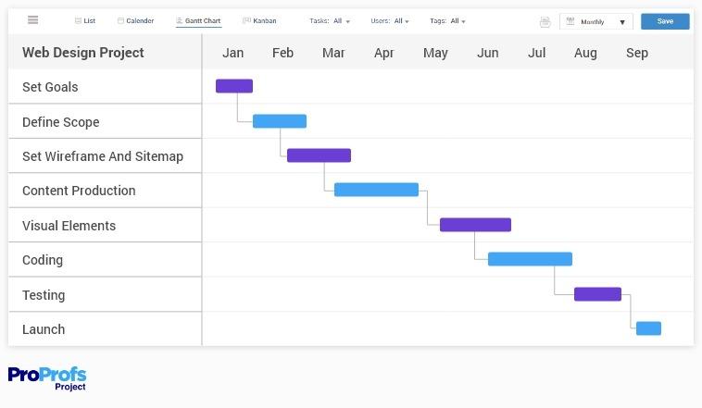

**Software Development Process:**

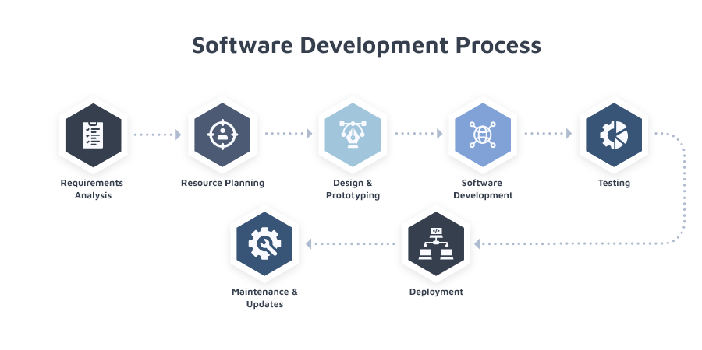

**Enhancing Work at UPTEK**

UPTEK have teams that manage themselves, encourage everyone to share ideas, provide training for skills, offer flexible jobs, communicate openly, reward good work with extra pay, and hire people who fit well with the team and the company.

**HR Operations and External Influences**

At UPTEK, HR involves things like finding, training, and managing employees. Outside factors, like the economy, technology changes, and laws, affect how we attract, develop, and keep talent, making sure our HR practices fit with what's happening outside the company.

**Strategic Human Resource Planning at UPTEK**

At UPTEK, they plan for the number of people they need, what skills they should have, and how to keep them happy. They do this by recruiting the best people, offering training to improve their skills, regularly checking how well they're doing, and creating programs to keep them working with them.

**Talent Acquisition and Company Appeal**

UPTEK find new people by posting jobs online, using social media, and connecting with others. They attract top talent by having a great company culture, showing career growth opportunities, and offering good pay. This way, they consistently bring in skilled professionals who fit with UPTEK and help the company succeed.

**Employee Selection and Recruitment Tools**

UPTEK use different tools to pick the right people, like interviews, technical tests, and checking references. These tools help them see if candidates have the right skills, knowledge, and if they'll fit well with in the company. Sometimes, they use tests or scenarios to get a better understanding of each candidate.

**Onboarding and Assimilation of New Employees**

UPTEK welcome new employees by helping them get used to our culture, rules, and work environment. They plan for their start by giving them training, assigning mentors, and making sure they have what they need to start working. This helps them feel comfortable and sets them up for success at UPTEK.

**Supporting Employee Performance and Growth**

UPTEK help employees do their best by setting goals, checking their progress regularly, and providing feedback. They use metrics, have reviews, and offer ongoing training. If someone needs help or wants to improve, they support them with feedback, clear expectations, and opportunities to grow within the company.

**Employee Compensation and Benefits at Uptek**

UPTEK decide how much to pay based on what's fair in the industry. They regularly check what others pay and offer competitive salaries. Besides pay, they provide benefits like health insurance, retirement plans, and extra perks. This shows their commitment to valuing and rewarding their employees.

**Managing HR Challenges at Uptek**

UPTEK handle challenges like reducing staff by being sensitive, communicating well, and supporting affected employees. For a diverse workforce, they focus on inclusive practices, offer diversity training, and create a workplace that values and celebrates differences. These efforts create a positive work culture and effective human resource management at UPTEK.

***Meeting Picture***

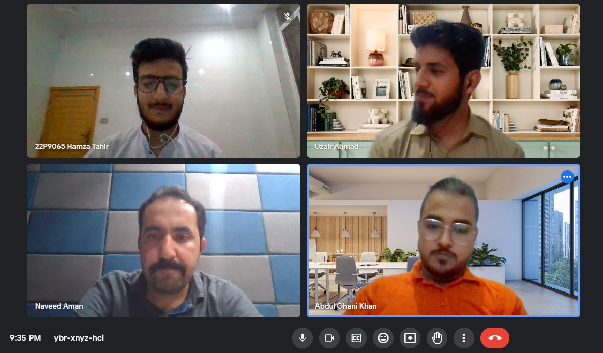

**Report – 4**

**How are tasks and responsibilities divided among the employees at UPTEK:**

we ensure efficient task distribution through a collaborative approach:

**Skill-Based Assignments:**

We match tasks with individual strengths and expertise.

**Project Teams:**

Formed to leverage complementary skills for project success.

**Rotational Responsibilities:**

Encourage team members to take on different roles for continuous growth.

**Project Managers:**

Dedicated managers oversee project planning and execution, ensuring effective task allocation.

**Regular Communication:**

Open discussions in team meetings facilitate transparent communication on workloads and updates.

**Flexibility:**

Embrace adaptability to meet changing project requirements and improve efficiency.

**UPTEK organizes its teams or departments:**

UPTEK organizes teams based on project requirements. We form project-specific teams, bringing together individuals with diverse skills to ensure a comprehensive approach. This dynamic structure allows us to adapt to varying project needs efficiently.

**Decision-making structured within UPTEK:**

At UPTEK, decision-making is collaborative. Project managers handle decisions within their projects, while department heads contribute to broader organizational decisions. Authority aligns with roles and responsibilities, fostering transparent communication.

**manager typically supervise:**

Each manager at UPTEK typically supervises a team of around 4 to 5 employees. This allows for effective communication, close oversight, and efficient coordination within the teams.

**UPTEK encourage employee empowerment and involvement in decision-making:**

UPTEK encourages employee empowerment through open communication, collaborative decision-making, skill development, task autonomy, feedback mechanisms, and recognition of contributions.

**UPTEK ensures specialized tasks and close teamwork through:**

**Skill-Based Task Allocation:**

Assigning tasks aligning with individual expertise.

**Project-Specific Teams:**

Forming teams with diverse skills for effective collaboration.

**Regular Team Communication:**

Facilitating close collaboration through regular team meetings.

At UPTEK, individuals take charge in project initiatives and innovation challenges. Communication happens through an open-door policy, regular team meetings, and digital platforms, promoting a dynamic and collaborative work environment.

***Regular Brainstorming Sessions:***

Team members participate in regular brainstorming sessions to generate fresh ideas and solutions.

***Client Feedback Integration:***

*Actively incorporating client feedback into processes to continuously improve and tailor our services.*

***Experimentation and Prototyping****:*

*Embracing a culture of experimentation and prototyping to test and implement new approaches.*

**UPTEK make sure things are done efficiently:**

***Remote Work Policies:***

Embracing remote work to reduce office-related expenses and provide flexibility to employees.

***Cloud-Based Tools:***

*Utilizing cloud-based tools for project management, collaboration, and storage, reducing infrastructure costs.*

***Optimized Resource Allocation:***

Carefully allocating resources based on project needs, avoiding unnecessary expenditures.

**UPTEK keep things simple and organized:**

**Project Management Tools:**

Using streamlined project management tools for task assignment, tracking, and communication.

**Regular Check-Ins:**

Conducting regular check-ins to ensure alignment and address any issues promptly.

**Skill Assessment:**

Evaluating individual strengths and expertise through skill assessments.

**Project-Specific Teams:**

Forming project teams with members possessing complementary skills for effective collaboration.

**Flexible Roles:**

Allowing individuals to take on roles that align with their strengths and interests.

**UPTEK addresses the need for specific expertise by:**

**Collaboration with Freelancers:**

Engaging freelancers or external specialists for short-term projects requiring specific skills.

**Networking and Partnerships:**

Building a network of external experts and forming partnerships to access specialized knowledge when needed.

**Training and Upskilling:**

Investing in internal training programs to develop in-house expertise for commonly required skills.

**UPTEK handle different parts of its business:**

UPTEK concentrates on its core competency of software development and online projects. For non-core functions like manufacturing, the company seeks external expertise, outsourcing or forming partnerships to ensure efficiency and quality.

**UPTEK encourage employees to do their best and succeed in their work:**

UPTEK promotes employee success through clear goals, regular feedback, and recognition programs. Professional development opportunities are provided, and a flexible work environment supports a healthy work-life balance, fostering overall achievement and motivation.

**Open Communication Channels:**

Maintaining open channels for employees to express ideas, concerns, and feedback.

**Collaborative Decision-Making:**

Encouraging team members to contribute to decisions, fostering a culture of shared responsibility.

**Regular Team Meetings:**

Conducting regular team meetings where everyone has an opportunity to influence and guide collective work.

This approach ensures that every individual has a voice and can contribute to the company's direction.

**UPTEK fosters a sense of connection by:**

**Team-building Activities:**

Organizing regular team-building events to strengthen relationships and camaraderie.

**Open Communication Channels:**

Maintaining open communication channels to encourage interaction and idea sharing.

**Cross-Functional Collaboration:**

Promoting collaboration across different teams, fostering a sense of unity.

**Social Events:**

Hosting social events and gatherings to create informal opportunities for employees to connect.

**UPTEK encourages positive behaviors through:**

**Recognition Programs:**

Implementing programs that acknowledge and reward exemplary performance.

**Incentive Structures:**

Offering incentives tied to individual and team achievements, motivating consistent positive actions.

**Performance Feedback:**

Providing regular feedback that highlights positive contributions and areas of improvement.

**Professional Development Opportunities:**

Linking career growth opportunities to positive behaviors, encouraging a commitment to excellence.

**There's behavior that the company wants to discourage:**

**Clear Expectations:**

Communicating clear expectations and standards of conduct to all employees.

**Constructive Feedback:**

Providing constructive and timely feedback to address specific instances of behavior misalignment.

**Progressive Discipline:**

Implementing a progressive discipline approach, escalating consequences if issues persist.

**Training and Support:**

Offering training and support to help employees align with expected behavior.

**Task Variety:**

Offering diverse tasks to keep work interesting and align with individual skills and interests.

**Autonomy and Responsibility:**

Providing autonomy in decision-making and responsibilities, empowering employees to take ownership.

**Professional Development:**

Offering opportunities for skill development and career growth, keeping employees engaged.

**Regular Feedback:**

Providing regular feedback to recognize achievements and guide improvement, fostering a sense of accomplishment.

**UPTEK enhances job variety by:**

**Cross-Training:**

Offering cross-training opportunities to expand skill sets and introduce new tasks.

**Project Rotation:**

Implementing project rotations, allowing employees to experience different aspects of the business.

**Task Expansion:**

Actively involving employees in decision-making and gradually expanding their responsibilities over time.

**Skill-Based Assignments:**

Aligning tasks with individual strengths and encouraging employees to take on projects that match their interests.

These approaches ensure that jobs remain engaging and provide opportunities for continuous learning and growth.

**Giving people more responsibility, how does UPTEK approach it:**

**Progressive Responsibility:**

Gradually increasing the complexity of tasks and projects based on performance.

**Leadership Opportunities:**

Offering opportunities for employees to take on leadership roles in projects or teams.

**Autonomous Projects:**

Allowing individuals to lead and manage their own projects, providing a higher level of autonomy.

**Mentorship Programs:**

Pairing employees with mentors to guide them in taking on more responsibilities.

**UPTEK decide what skills and talents are needed:**

**Job Analysis:**

Conducting a thorough analysis of the job to identify specific skills and talents needed.

**Skill Assessments:**

Assessing individual employee skills and aligning them with job requirements.

**Cross-Functional Training:**

Providing training opportunities that allow employees to develop and use a variety of skills.

**Feedback and Evaluation:**

Regularly evaluating performance and seeking feedback to identify areas for skill development.

**UPTEK ensures that employees have a chance to use a variety of skills in their roles:**

UPTEK determines the variety of skills needed through job analysis and skill matrices. Employees have opportunities to use a variety of skills based on project requirements and receive training to enhance their capabilities.

**UPTEK ensure that it contributes to a complete piece of work:**

We ensure task contributions lead to a complete piece of work by setting clear objectives, fostering collaborative planning, and providing regular progress updates. Jobs are structured to create a sense of accomplishment through recognition and feedback upon task completion. For instance, in software development, individual coding tasks contribute to completing features, and successful completion is acknowledged, reinforcing a sense of achievement.

**UPTEK ensures that employees receive feedback on their performance:**

We provide feedback through regular performance reviews, project evaluations, and open communication channels for peer and managerial feedback. Recognition programs further acknowledge individual and team accomplishments, fostering continuous improvement and a clear understanding of performance.

**does UPTEK make sure that everyone is treated fairly:**

We ensure fair treatment by offering equitable compensation, performance-based recognition, and transparent policies. The company values open communication, allowing employees to voice concerns and provide feedback on perceived fairness. This approach emphasizes a correlation between effort and recognition, contributing to a work environment where everyone feels valued and treated fairly.

**UPTEK manage the balance between what employees:**

Equitable Compensation: Offering fair and competitive compensation aligned with individual contributions.

**Recognition Programs:**

Acknowledging and rewarding employees based on performance, fostering a sense of appreciation.

**Performance Reviews:**

Conducting regular performance reviews to assess contributions and provide constructive feedback.

**Transparent Policies:**

Implementing transparent policies to ensure consistency and fairness in all aspects of employment.

**UPTEK make sure that employees believe:**

Ans: We ensure employee belief in outcome through clear goal setting, performance recognition, individualized rewards, and regular communication, aligning individual efforts with desired outcomes and creating a motivating work environment.

**UPTEK understand what employees really want:**

We understand employee desires by conducting individual assessments and surveys to identify personal goals. The company then aligns rewards with these preferences through customized programs. For example, if an employee values professional development, UPTEK may offer training opportunities as a reward. This tailored approach ensures that goals and rewards resonate with individual motivations, enhancing overall employee satisfaction and motivation.

**Clear Performance Metrics:**

Establishing clear performance metrics tied to individual and organizational goals.

Regular Performance Feedback:

Providing regular performance feedback to help employees gauge the impact of their efforts.

Recognition and Rewards:

Implementing recognition and reward systems tied to meaningful outcomes, reinforcing the connection between effort and success.

For instance, meeting project milestones could be recognized through performance feedback and rewarded with incentives, fostering the belief that hard work directly contributes to positive results.

**UPTEK connects performance with desirable outcomes by**:

**Transparent Performance Metrics:**

Clearly communicating the performance metrics and criteria for rewards or recognition.

Employee of the Month Program:

Implementing programs like "Employee of the Month" where outstanding performance is publicly acknowledged.

**Tailored Rewards:**

Offering rewards that align with individual preferences, making the connection between performance and desired outcomes more tangible.

For instance, being chosen as "Employee of the Month" not only provides public recognition but may also come with additional benefits or incentives, creating a direct link between excellent performance and desirable outcomes at UPTEK.

UPTEK ensures leader effort by setting ambitious goals, recognizing initiative, and offering professional development opportunities. Leaders are motivated by transparent career paths and recognition, fostering a culture of ambition and energy within the company.

UPTEK ensures leaders take charge and influence the team by empowering them to make decisions and take ownership. The company provides leadership training to enhance their skills and maintains open communication channels, encouraging leaders to voice their ideas and decisions. By recognizing and appreciating effective leadership, UPTEK reinforces a culture where leaders confidently take responsibility for their decisions. This support contributes to a proactive and influential leadership style, positively impacting team dynamics and project outcomes.

**UPTEK involves employees in decision-making by:**

**Open Forums:**

Conducting open forums where employees can share ideas and provide input on decisions.

**Decision Workshops:**

Organizing decision workshops to gather diverse perspectives and insights.

**Employee Committees:**

Establishing employee committees that contribute to specific decision-making processes.

**Anonymous Feedback Channels:**

Providing anonymous feedback channels to encourage open expression of opinions.

This democratic approach ensures that employees have a voice in decisions, fostering a collaborative and inclusive leadership style at UPTEK

**UPTEK decides leadership and authority by:**

**Project Scope:**

Deciding based on the scope and nature of the project; complex projects may involve centralized decision-making, while more routine tasks allow for team autonomy.

**Team Expertise:**

Delegating decisions to teams with relevant expertise, ensuring the most informed choices.

Collaborative Decision-Making:

Encouraging collaborative decision-making for strategic and cross-functional matters, allowing diverse input.

**Leadership Training:**

Providing leadership training to ensure managers are equipped to balance dictating work methods and allowing group freedom based on the situation.

**UPTEK balances concern for people and work by:**

**Employee Well-being Initiatives:**

Implementing well-being programs and initiatives to show concern for employees' happiness and health.

**Performance Metrics:**

Evaluating managers based on both team performance metrics and employee satisfaction surveys.

Flexible Work Policies:

Offering flexible work policies that prioritize work-life balance, demonstrating concern for employees' personal lives.

Leadership Training:

Providing leadership training that emphasizes the importance of balancing task-oriented and people-oriented approaches.

By considering both task and people-oriented aspects in performance evaluations and fostering a culture of empathy, UPTEK ensures a well-rounded approach to leading teams.

**UPTEK prevents a leadership style that neglects both people and production by:**

**Performance Reviews:**

Incorporating balanced metrics in performance reviews, evaluating both task accomplishment and team collaboration.

360-Degree Feedback:

Utilizing 360-degree feedback mechanisms to gather input from peers, subordinates, and superiors, providing a comprehensive view of leadership effectiveness.

Leadership Development Programs:

Offering leadership development programs that emphasize the importance of balancing people and task-oriented approaches.

Regular Check-Ins:

Conducting regular check-ins with team members to assess both individual well-being and project progress.

**UPTEK ensures leaders focus on both tasks and people by:**

**Clear Expectations:**

Establishing clear expectations for task completion while emphasizing the importance of a healthy work-life balance.

**Flexible Work Policies:**

Implementing flexible work policies that accommodate individual needs, promoting employee well-being.

**Performance Recognition:**

Recognizing and rewarding leaders who achieve task goals while also fostering a positive team culture.

**UPTEK ensures leaders create a vision by:**

**Strategic Planning Sessions:**

Conducting strategic planning sessions to define and articulate a compelling vision for the future.

Encouraging Innovation:

Fostering a culture of innovation that encourages leaders to envision and implement improvements beyond the present situation.

UPTEK ensures its leaders create a vision for the future by facilitating strategic planning workshops that guide leaders in formulating compelling and realistic visions. The company encourages leaders to seek input from employees, fostering a collaborative vision that integrates diverse perspectives. Additionally, UPTEK promotes innovation initiatives, challenging leaders to improve the present situation by envisioning and implementing strategic improvements. This approach ensures that the organization's goals and direction are shaped by a shared and forward-thinking vision that aligns with both the aspirations of its leaders and the broader team.

UPTEK ensures its leaders foster moral virtue among team members by promoting a culture of ethics and positive behavior. The company emphasizes ethical leadership through training programs, encourages open communication to address ethical concerns, and recognizes and rewards employees who demonstrate moral virtues. This approach creates an ethical work environment where attitudes and behaviors align with the company's values, fostering a culture of integrity and mutual respect among team members.

UPTEK ensures its leaders have a clear vision for the future by providing support and resources that enable effective leadership. The company conducts strategic planning sessions to help leaders formulate a compelling vision. Additionally, UPTEK fosters a culture of innovation, encouraging leaders to envision positive changes and improvements. This support, combined with a commitment to ongoing training and development, enables UPTEK's leaders to provide a positive and forward-thinking direction for their teams.

UPTEK supports leaders by creating an environment that values innovation, where exploring new ideas and solutions is encouraged. This approach empowers leaders to proactively identify and address challenges, contributing to a dynamic and responsive organizational culture.

Communication is the process of exchanging information, ideas, thoughts, or feelings between individuals or groups. It involves the transmission and reception of messages through various channels, such as verbal and non-verbal means, to convey meaning and understanding.

**Interpersonal Communication:**

Interpersonal communication refers to the exchange of information, feelings, and meaning between two or more people. It involves face-to-face interactions, and the effectiveness of interpersonal communication depends on factors such as active listening, verbal and non-verbal cues, and the ability to understand and respond to the emotions of others. Interpersonal communication is crucial in building and maintaining relationships, resolving conflicts, and creating a sense of connection.

**Organizational Communication:**

Organizational communication focuses on the exchange of information within a structured environment, such as a company or any other organized group. It includes both formal communication, such as official memos and reports, and informal communication, like water-cooler conversations. Effective organizational communication is essential for the functioning and success of an organization. It helps in conveying the mission and goals, coordinating activities, making decisions, and fostering a positive work culture. Clear channels of communication within an organization contribute to employee engagement, productivity, and overall organizational success.

evaluating communication methods involves considering various factors to determine the most appropriate approach for a given situation

**Feedback:**

The extent to which the communication method allows for feedback or two-way communication.

Importance: Feedback is crucial for ensuring that the message is understood and for clarifying any misunderstandings.

**Confidentiality:**

The degree to which the communication method ensures the privacy and protection of sensitive information.

**Importance:**

Some information may require a high level of confidentiality, and the chosen method should align with those requirements.

**Time-Space Constraint**:

The limitations on when and where communication can take place.

Importance: Considering time and space constraints is essential for ensuring timely and effective communication, especially in a global or remote work environment.

**Cost:**

The financial resources required for implementing a particular communication method.

Importance: Cost-effectiveness is a significant consideration, especially for organizations with budget constraints.

**Formality:**

The degree of formality associated with the communication method.

Importance: The formality of communication can impact the tone and professionalism of the message, and it should align with the context and audience.

**Time Consumption:**

The amount of time required to convey or receive a message using a specific communication method.

Importance: Efficiency is crucial, and choosing methods that minimize time consumption is important, especially in fast-paced environments.

Non-verbal communication involves the transmission of messages or information without the use of words. It includes gestures, facial expressions, body language, posture, eye contact, and other non-verbal cues that convey feelings, attitudes, and meaning. Non-verbal communication often complements verbal communication and plays a crucial role in expressing emotions, building relationships, and enhancing the overall understanding of a message.

**Filtering:** Filtering refers to the intentional manipulation of information to present it in a way that appears more favorable or acceptable to the receiver.

Importance: This can impact the accuracy and transparency of communication, as it involves selectively sharing information to influence perceptions.

**Emotions:**

Emotions in communication involve the process of disregarding rational and objective thinking, substituting emotional judgments when interpreting messages.

Importance: Emotional responses can significantly influence how individuals perceive and react to information, shaping the overall communication experience.

**Information Overload:** Information overload occurs when an individual is confronted with a quantity of information that exceeds their capacity to effectively process and absorb.

Importance: Too much information can lead to difficulties in decision-making, reduced attention, and a decline in the overall effectiveness of communication.

**Managing Communication in an Internet World:**

**Information Overload**: With the vast amount of information available online, people may struggle to filter and prioritize relevant information.

Digital Fatigue: Constant connectivity can lead to burnout and exhaustion, affecting the overall well-being of individuals.

**Legal and Security Issues:**

Privacy Concerns: Growing awareness and concerns about privacy breaches, data misuse, and surveillance.

**Cybersecurity Threats:**

The risk of cyberattacks, hacking, and data breaches pose significant challenges to secure communication.

Lack of Personal Interaction:

**Loss of Non-Verbal Cues:**

Digital communication often lacks the richness of face-to-face interactions, making it challenging to interpret nuances and emotions accurately.

Isolation and Alienation: Overreliance on digital communication can contribute to feelings of isolation and reduce the sense of genuine connection.